Pulsed NMR Lab

*By: Alex Liechty, Meghna Shankar, Crystal Nelson, Junhua Deng*

*Date: March 31, 2022-April 7, 2022*

## Theory Exercises (3/31/2022; CN, AL, MS):

1. 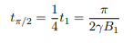pi/(2*27650*12) = **tpi/2=4.73ms**. The time constant for a pi/2 pulse is inversely proportional to the given values.
2. (same equation as above) pi/2 time constant = 6.176 microseconds; **B= 9.206 Gauss**. The B value is inversely related to the time constant.
3. The **maxima are at odd integer multiples of tpi/2** and the **minima are at even integer multiples of tpi/2**. For odd integer multiples of tpi/2 the net magnetization M has its maximum projection onto the x-y plane. Since the z direction is that of the static magnetic field B0, this means that a pulse with width of an odd integer of tpi/2 rotates M by an odd multiple of pi/2 to lie in the x-y plane. When the pulse has width that is an even integer of tpi/2, then M is rotated by an integer multiple of pi, which means it lies either parallel or antiparallel to B0 and the x-y projection of M is minimized. These rotations are why the pulses are called pi/2 pulses and pi pulses respectively.

## Experiment 1 Background and Setup (3/31/2022-4/7/2022 CN, AL, MS)

Measure T1 and T2 for the following materials: mineral oil, Vaseline, glycerine, water, and ethyl alcohol (ethanol).

Equipment settings:

* Frequency for optimal pulse: 14.77MHz (for every liquid)
* Tuned counterclockwise 30 degrees

Diagram with annotations (including signal paths):

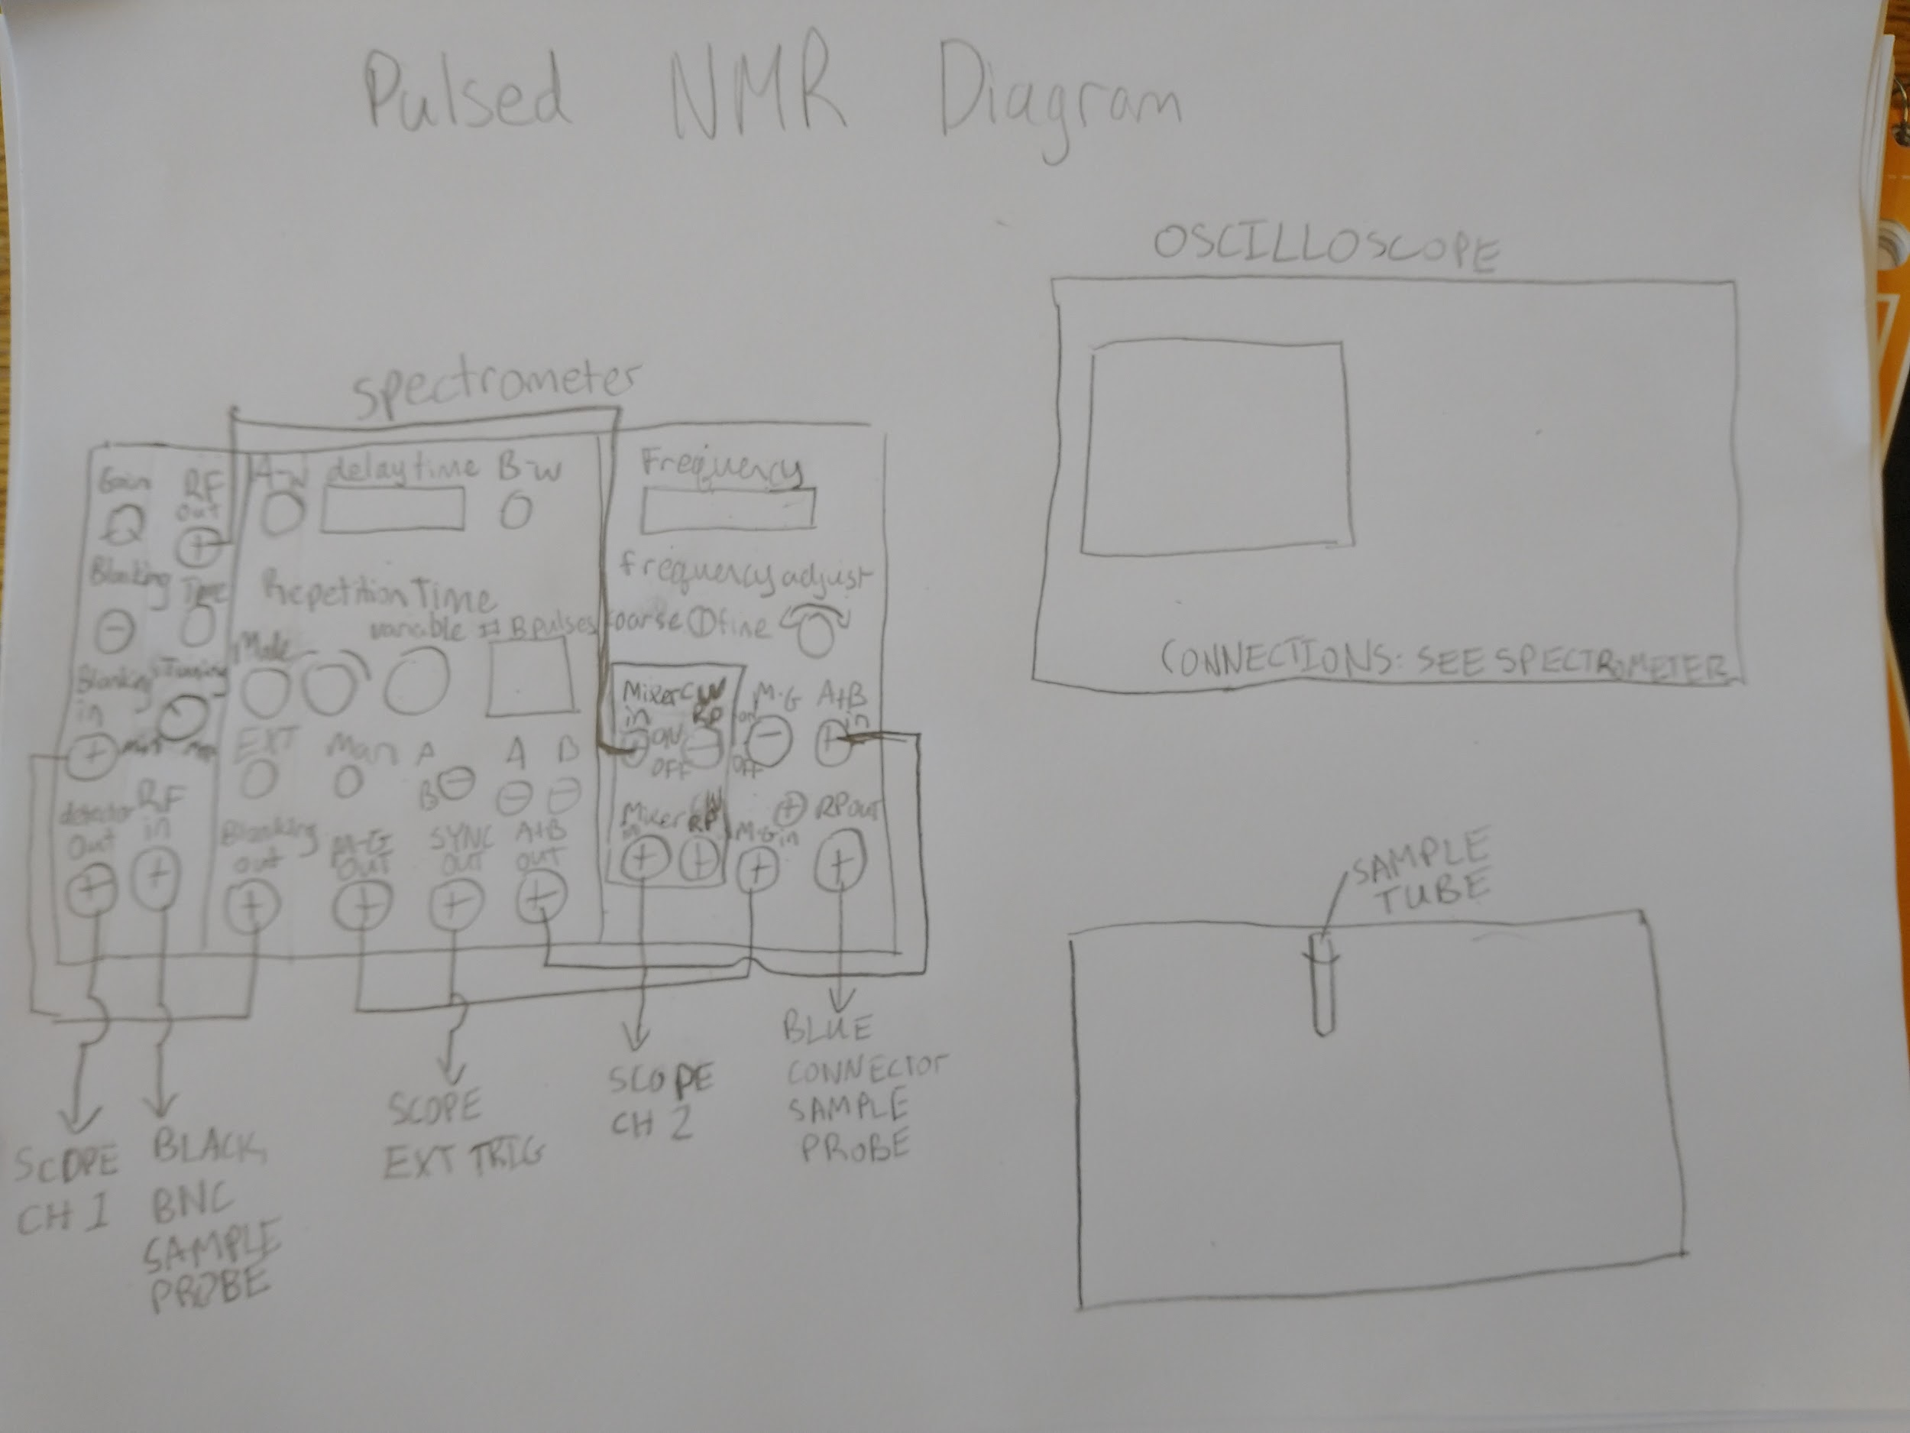

Sketch of equipment set up, sample tube is placed in a strong magnet and apparatus is used to pulse the sample with resonant RF pulses in order to perform the experiments done in this lab.

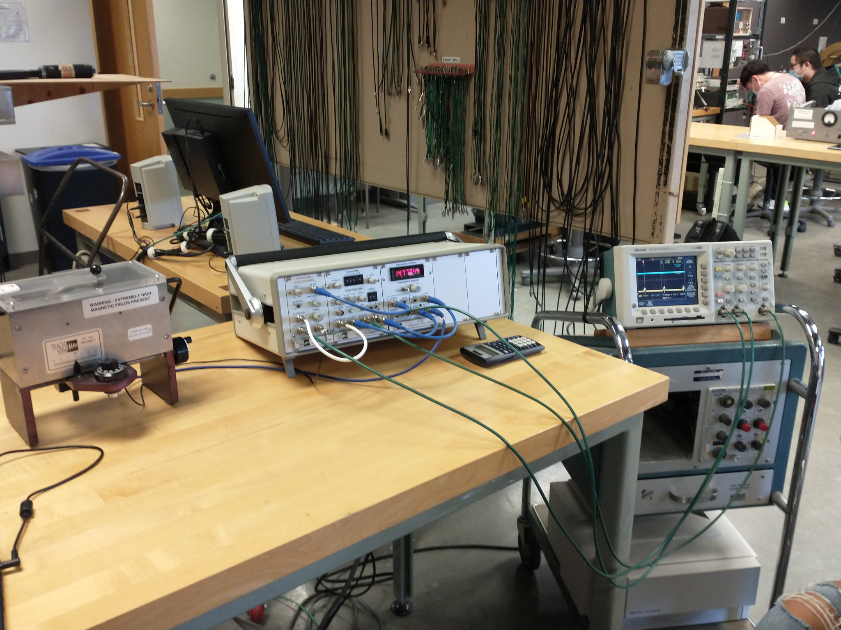

Image of the apparatus used to perform the experiments. On the left is the magnet and detector where samples were inserted. In the middle is the receiver, pulse programmer, and oscillator that allowed us to use pulsed NMR to take measurements. On the right is the oscilloscope used to read measurements 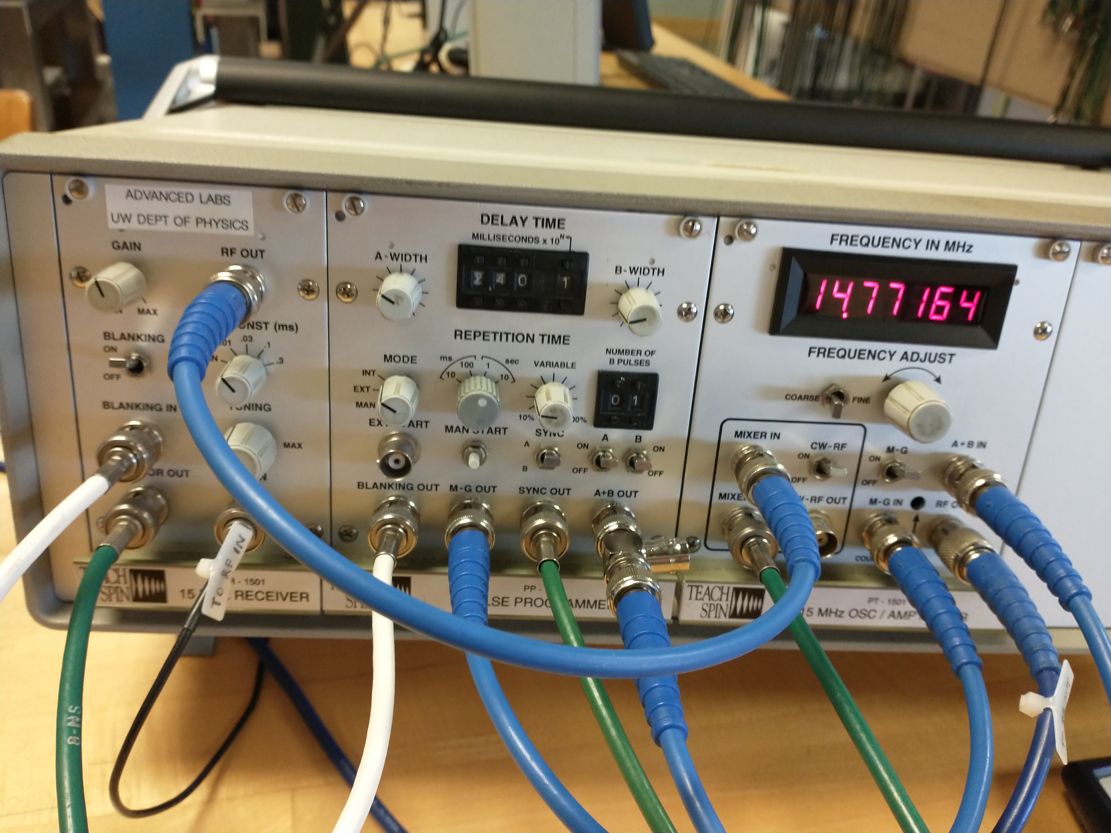

Image of the receiver, pulse programmer, and oscillator used to find the resonant frequency, control A and B pulses, send pulses to the sample, and send readings to the oscilloscope.

## Experiment 1 Data Reduction and Preliminary Results (3/31/2022-4/7/2022 CN, AL, MS, JD)

For our experiment, we first measured T1 by setting the A pulse to be a pi pulse, and the B pulse to be a pi/2 pulse. This means M would be flipped antiparallel to the magnetic field, and then rotated by pi/2 by the B pulse. We were able to determine T1 by changing the delay time between pulses A and B such that the FID signal was zero after the B pulse. This delay time was the half-life of the decay from M being in the -z direction to M being in the +z direction. This means that T1 = (delay time) / ln(2).

To measure T2 we set A to be a pi/2 pulse and set B to be a pi pulse in order to create spin echos. The envelope function for these spin echoes has a half life of T2, so we measured the time it took for the magnitude of the spin echoes to be half of the initial magnitude, and then divided that time by ln(2) to get T2. For water the resolution on the oscilloscope did not allow for an accurate measurement, so we needed to use a linear approximation method (shown and discussed below in calculations).

Here are the calculations we used for T1 and T2:

T1 = (crossing time) / (ln2)

**Mineral Oil T1=**24ms/(ln2)= **34.6ms**

**Vaseline T1=** 30ms/(lvbn2)= **43.3ms**

**Glycerine T1=** 51ms/(ln2)= **73.6ms**

**Ethanol T1=** 400ms/(ln2)= **577.1ms**

**Water T1=** 1200ms/(ln2)= **1731.3ms**

*Note: when we used the other method of measuring the time values from which we were to calculate T1 and T2 for mineral oil (as a test), there was a large discrepancy from both the official methods for this report and the true values we were supposed to get.

T2 = (measured time)/(ln2), where measured time is the time between the first spin echo, and the time that the spin echoes were half the magnitude of the initial spin echo. For water, we used a linear approximation to measure T2 using the first order expansion of V0Exp(-t/T2) which gives T2 -V0/{(V2-V1)/(t2-t1)}.

**Mineral Oil T2=** 29.9ms/(ln2)= **43.1ms**

**Vaseline T2=** = 20.0ms/(ln2)=**36.1ms**

**Glycerine T2=** 45.2ms/(ln2)= **65.2ms**

**Ethanol T2=** 104ms/(ln2)= **150.0ms**

**Water T2=** ms/(ln2)= **706.3ms**

* **First echo V1: (10.1V) Second echo: (9.96V) Delta t = 2.00ms**
* **Linear Approximation: Slope = -0.0143**
* **T2 = 706.3ms**

Our raw data did not originally seem to agree with the expected values or trends. We expected an inverse relationship between the viscosity of the liquid and its time constant, but we did not consistently get this result. For example, our T1 for ethanol did not fit this relationship. We also did not sync on the B pulse originally for the T2 data.

We had to redo T2 for all of the data as well as T1 for ethanol. Our subsequent data, tabulated below, follows the expected trends better, though still somewhat imperfectly:

|  |  |  |  |  |  |
| --- | --- | --- | --- | --- | --- |
|  | Mineral Oil | Vaseline | Glycerine | Ethanol | Water |
| T1 (ms) | 34.6 | 43.3 | 73.6 | 577.1 | 1731.3 |
| T2 (ms) | 43.1 | 36.1 | 65.2 | 150.0 | 706.3 |

For this table, it was relatively simple as we did not have to do more than one trial for each (except for the ones we had to redo), so there were no uncertainty values to discuss. The trends with viscosity for T1 were as expected. For T2, our larger time values (for glycerine and ethanol) agree with the expected trends, but T1 is not much greater than T2 as we expected for mineral oil and vaseline. Thus, the uncertainty is higher on the smaller values.

Experiment 1 Final Analysis (4/5/2022-4/7/2022 CN, AL, MS, JD)

Our calibrations specific to our experiment were using a 14.770 MHz pulse and rotating the tuning rod counterclockwise approximately 30 degrees.

We did not have to carry out uncertainty analysis for this experiment other than comparing our data to expected values and trends to see if we were on the right track. [Comparing the values to expected numbers for T1 and T2 and the relationship trends expected across T1 trials (like longer times for lower viscosity fluids), or when comparing T1 and T2 trials (T1>>T2 for early trials), sometimes showed if the calibration we used was off and we needed to retake data.] However, qualitatively, the main sources of uncertainty include volume of the drops we put into the tubes, the positioning of the tubes in the reader, calibrating the optimal frequency and tuning the use, and reading off the time values from the oscilloscope.

## Experiment 1 Assessment and Discussion (4/7/2022 CN, AL, JD)

The values we measured for experiment 1 do not seem to align with known results. First of all, It is expected that T2 $≤$ T1 which we did not measure for mineral oil. From theory we should expect that for high viscosity T1 should be significantly larger than T2, but for the high viscosity materials, we still measured a T2 that is close to T1. Additionally, it was expected that T2 should approach T1 as viscosity increases, but we were unable to observe this as well.

The comparison of our results with theory leads to the conclusion that we made mistakes when performing this experiment. Looking at the measured values of T2 for the high viscosity materials it is possible that we started with a delay time past the first zero crossing and found a longer delay time that appeared to give us a zero crossing. Additionally this was our first time making measurements with this apparatus, so it is possible that mistakes were made with setting up the gain and tuning, or with reading the oscilloscope.

Additionally, there are a variety of environmental factors that can affect viscosity such as temperature which were not controlled. It is possible that we were not careful enough when putting the sample into the apparatus which would cause the samples to not be aligned with the static magnetic field, affecting the resonant frequency, and both T1 and T2.

A combination of mistakes setting up the apparatus, and a failure to control environmental factors could explain the strange results, particularly T2 for mineral oil. We discussed returning to this experiment and taking new measurements, but we ultimately ran out of time to do so.

## Experiment 2 Background and Setup (4/5/2022 CN, AL, JD)

See experiment 1 for diagram.

Description: For the general setup, this is the same as it was for experiment 1.

For the ¼ solution, we took three drops of water and one drop of CuSO4 and mixed them, then measured the time constant we needed for our calculations. For the 1/16th solution, we put one drop of this well-mixed solution plus three drops of water into the vessel. For each subsequent solution, we repeated the process with the last solution. (For example, we made the 1/64th concentration solution from the 1/16 concentration solution.)

## Experiment 2 Data Reduction and Preliminary Results (4/5/2022 CN, AL, MS)

Using the same method as experiment 2, both T1 and T2 were measured for different dilutions of CuSO4 and water. We started with a sample with a dilution ¼ CuSO4 and ¾ water. We proceeded to take one drop from the mixture and 3 drops of water, increasing the dilution by powers of ¼. The measured values are tabulated below.

T1 = measured value/(ln2):

1/4 Solution: 2.5ms/(ln2) = **3.6ms**

1/16 Solution: 10.3ms/(ln2) = **14.9ms**

1/64 Solution: 120ms/(ln2) = **173.1ms**

1/256 Solution: 250ms/(ln2) = **360.7ms**

1/1024 Solution: 550ms/(ln2) = **793.5ms**

1/4096 Solution: 1300ms/(ln2) = **1875.5ms**

T2 = measured value/(ln2):

1/4 Solution: 3.0ms/(ln2) = **4.3ms**

1/16 Solution: 13.6ms/(ln2) = **19.6ms**

1/64 Solution: 48.0ms/(ln2) = **69.2ms**

1/256 Solution: 70.4ms/(ln2) = **101.6ms**

1/1024 Solution: 70.0ms/(ln2) = **101.0ms**

1/4096 Solution: 84.0ms/(ln2) = **121.2ms**

These results are tabulated below:

|  |  |  |  |  |  |  |
| --- | --- | --- | --- | --- | --- | --- |
|  | 1/4 | 1/16 | 1/64 | 1/256 | 1/1024 | 1/4096 |
| T1 (ms) | 3.6 | 14.9 | 173.1 | 360.7 | 793.5 | 1875.5 |
| T2 (ms) | 4.3 | 19.6 | 69.2 | 101.6 | 101.0 | 121.2 |

Our initial data all lined up with the trend predictions we had except for the 1/1024 solution T2 data. Initially, we calculated a time constant of 92.9, which was out of line with the expected trend for the data. Our next trial gave 101.0 ms, which was still out of line but closer to the expected value.

Experiment 2 Final Analysis (4/7/2022 CN, AL, JD)

We did not have to carry out uncertainty analysis for this experiment other than comparing our data to expected values and trends to see if we were on the right track. [Comparing the values to expected numbers for T1 and T2 and the relationship trends expected across T1 trials (tending towards that of water), or when comparing T1 and T2 trials for the more dilute solutions (T1>>T2 for later trials) sometimes showed if the calibration we used was off and we needed to retake data or explain the issues we had.] However, qualitatively, the main sources of uncertainty include the uncertainty on the concentration of the solution due to the inexact nature of the droplet dilution method, volume of the drops we put into the tubes, the positioning of the tubes in the reader, calibrating the optimal frequency and tuning the use, and reading off the time values from the oscilloscope.

A plot of the concentration of Cupric Sulfate 5 Hydrate vs our measurements for T1 and T2 on a log-log scale is:

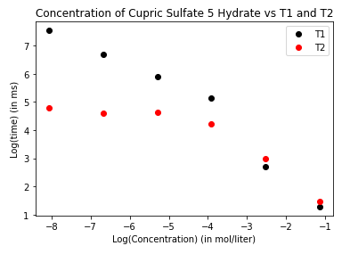

## Experiment 2 Assessment and Discussion (4/7/2022 CN, AL, JD)

“From Getting Started with Group Notebooks:

We compared our measured values to the Hahn paper provided. In the paper Hahn plotted measurements as:

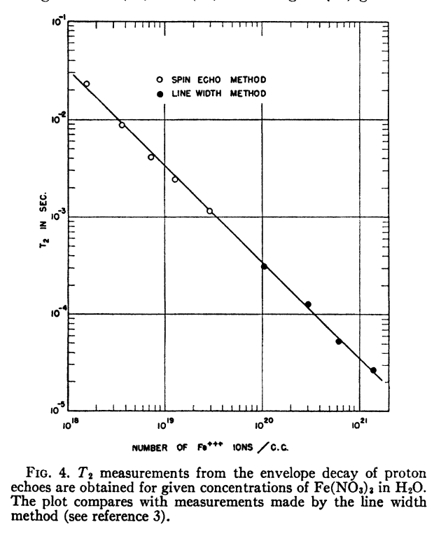

Unfortunately, this did not agree with our data for T2. As seen in our graph, the relationship appeared to be linear (on a log-log scale) until a dilution number 4. This is interesting because our measured values for T1 did appear to follow the expected linear trend on a log-log scale. Since CuSO4 is magnetic we would expect T2 to be much shorter than T1 since the internal spin-spin interactions would be stronger. We do see this general trend in our data, but we still do not see a linear relationship between concentration and T2 on a log-log scale.

We determined that there are many places we could have made mistakes. First of all, we had a very inexact method of creating solutions. We took one drop from our previous solution and added 3 drops of water which is not exact enough for such small dilutions. Additionally we could have had the samples at different depths in the magnet which could affect the peak voltage readings. If we were to redo this experiment we would be more careful with creating our mixtures, and also verify that the position of the samples was such that the peak amplitudes were maximized.

## Experiment 3 Background and Setup (4/5/2022-4/7/2022 CN, AL, JD)

See experiment 1 for diagram.

In experiment 3 we measured the peak voltage of the first spin echo at different delay times in order to determine the envelope function of the spin echoes. To do this we used a water sample and the same electronics setup as the previous experiments.

## Experiment 3 Data Reduction and Preliminary Results (4/7/2022 CN, AL, JD)

Frequency: 14.777MHz

Other settings were the same as previous experiments

**Water data table:**

|  |  |  |  |  |  |  |  |  |  |  |  |  |
| --- | --- | --- | --- | --- | --- | --- | --- | --- | --- | --- | --- | --- |
| Delay Time (ms) | 0.1 | 0.5 | 1.0 | 2.5 | 5.0 | 7.5 | 10.0 | 12.5 | 15.0 | 17.5 | 20.0 | 50.0 |
| Peak voltage (V) | 7.24 | 6.92 | 6.88 | 6.88 | 6.66 | 6.00 | 4.96 | 3.60 | 2.38 | 1.56 | 0.76 | 0.84 |

There was a slight downward trend in the peak voltages as the delay time we used increased. The first 2 data points were larger than Mi which was confusing because this should not be possible using the provided formula. The 50 ms measurement also increased in amplitude which also is not expected theoretically. Overall, from 1ms to 20ms the trend we saw in our data is what we expected based on the theory discussed below.

We manipulated this data for our analysis by dropping the 0.1, and 0.5 ms measurements because we determined that these times are so short that the peak voltage of these spin-echo signals could be affected by the FID signal. We also dropped the 50 ms measurement because on this time scale it was difficult to measure the peak voltage, so we did not think that the accuracy of that measurement was acceptable.

Experiment 3 Final Analysis (4/7/2022 CN, AL, JD)

Our calibrations specific to our experiment were using a 14.777 MHz pulse and rotating the tuning rod counterclockwise approximately 30 degrees.

A plot of our data along with the initial fit function and the best fit function is:

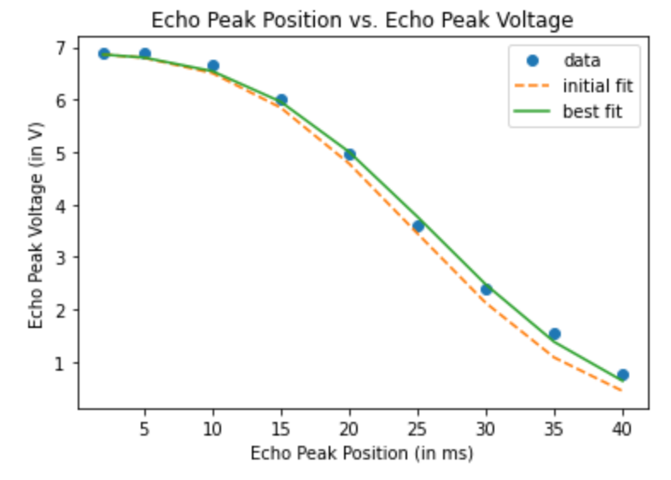

In the literature provided, Hahn, Carr and Purcell derived the following formula for the envelope function of spin echo amplitude:

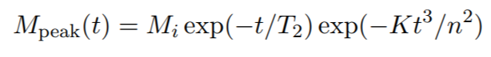

Since we used water to make these measurements, we had measured T2 = 706.3 in experiment 1, we made measurements using a single B pulse, so n = 1, and we could measure Mi which we measured to be 6.88.

In order to find an initial value of K to fit our data we plugged in t = 12.5 ms and our measured result of Mpeak = 3.6 V. We solved for K and our initial fit used K = 4.2e-5. As can be seen in the graph, this initial fit was close to the best fit, and our data followed the trend of the best fit.

## Experiment 3 Assessment and Discussion (4/7/2022 CN, AL, JD)

Unlike experiments 1 and 2, the results we had for experiment 3 were in agreement with the expected spin echo decay. As can be seen in the graph, not only did the best fit curve match our data well, but the initial fit curve using the K value we calculated from the formula was also close to our data. The experiment instructions said to not concern ourselves with uncertainty so it is difficult to determine how well our data matches the line of best fit, but the general trend of the curve can clearly be observed in our data.

We did have to remove some data points from our analysis as discussed above, but the data points we removed would not affect the general trend in the data, the points were just determined to be inaccurate measurements because of the methods used to make measurements.

Additionally, the fact that the results from this experiment were more in line with the theoretical results could be due to the fact that we used a single water sample without removing it. This means that problems with the sample being aligned with the magnetic field properly or with temperature were consistent throughout these measurements. This helped us make conclusions about questionable results from the previous 2 experiments.